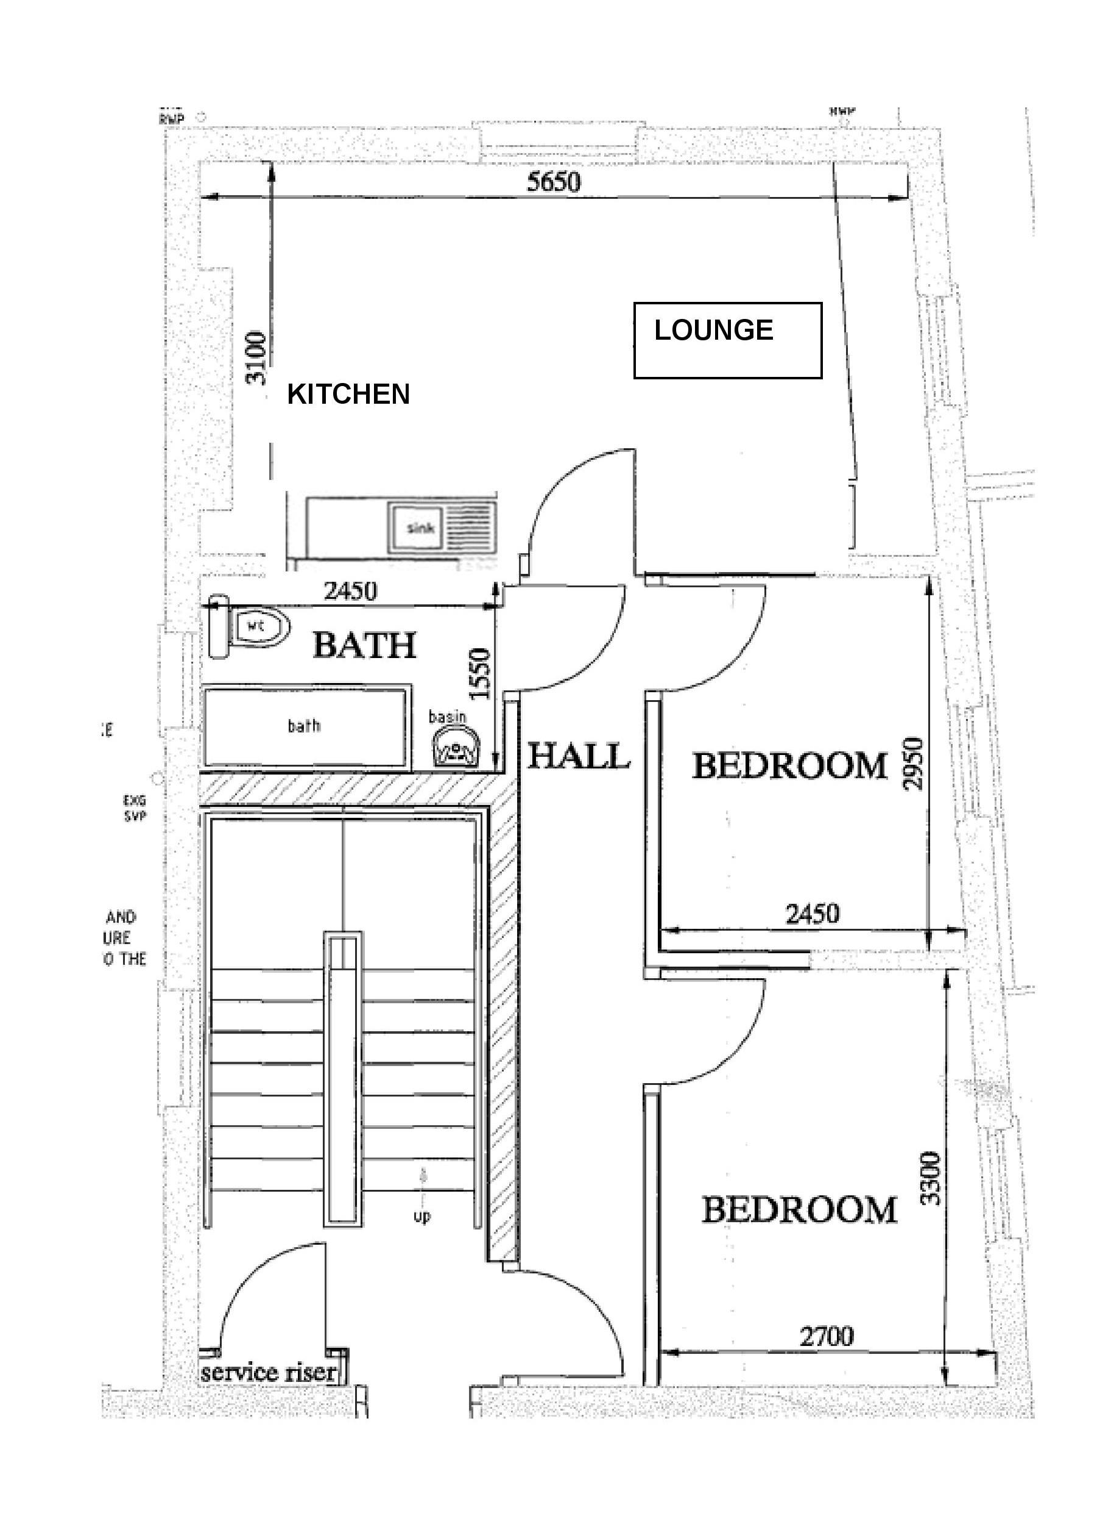
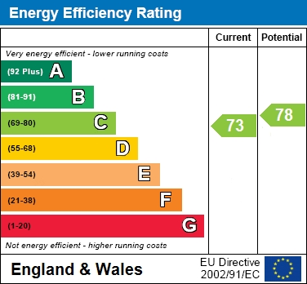
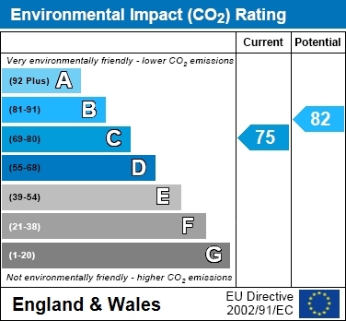
New Street | St Neots

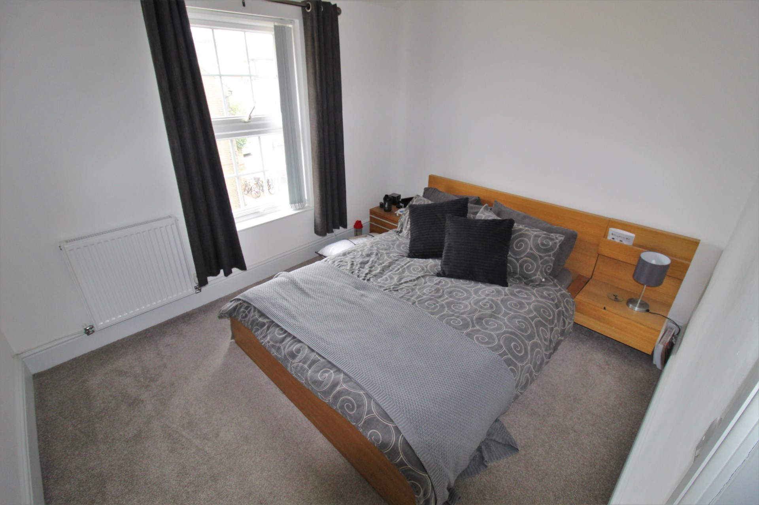
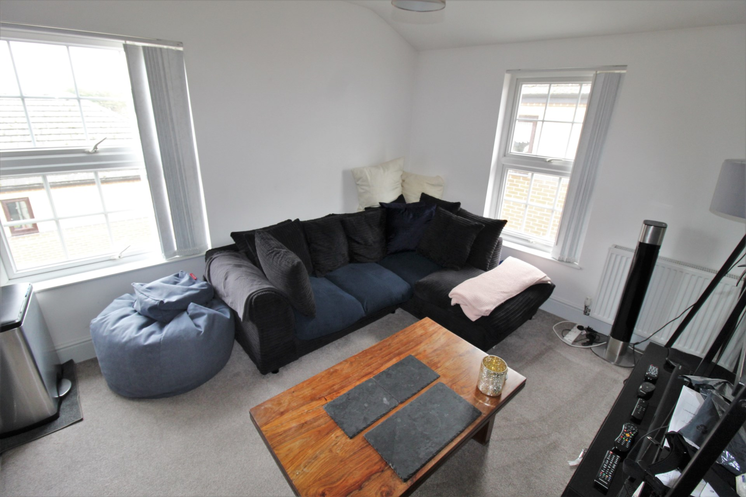
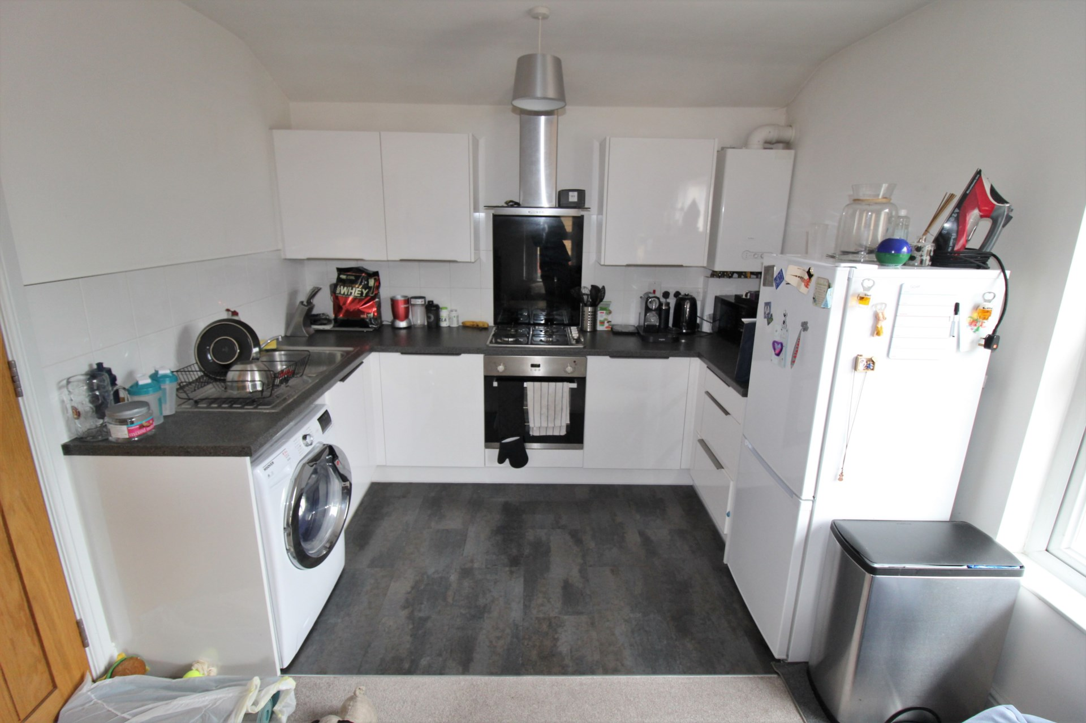

- EXTREMELY WELL PRESENTED
- TOP FLOOR APARTMENT
- TWO DOUBLE BEDROOMS
- MODERN KITCHEN
- OPEN PLAN LIVING ROOM
- MODERN BATHROOM WITH SHOWER FACILITIES
- NEUTRAL DECOR THROUGHOUT
- GREY FITTED CARPETS
- PRIVATE ALLOCATED PARKING
- DOUBLE GLAZING & GAS CENTRAL HEATING

Price £795 pcm

Extremely Well Presented Town Centre Apartment Offering Spacious Accommodation. Hallway, Modern Fitted Kitchen, Living Room, Two Double Bedrooms, Modern Bathroom with Shower. Double Glazing & Gas Central Heating. Neutral Decor & Grey Carpets. Intercom & Private Parking. No Pets. Available 17/08/21

