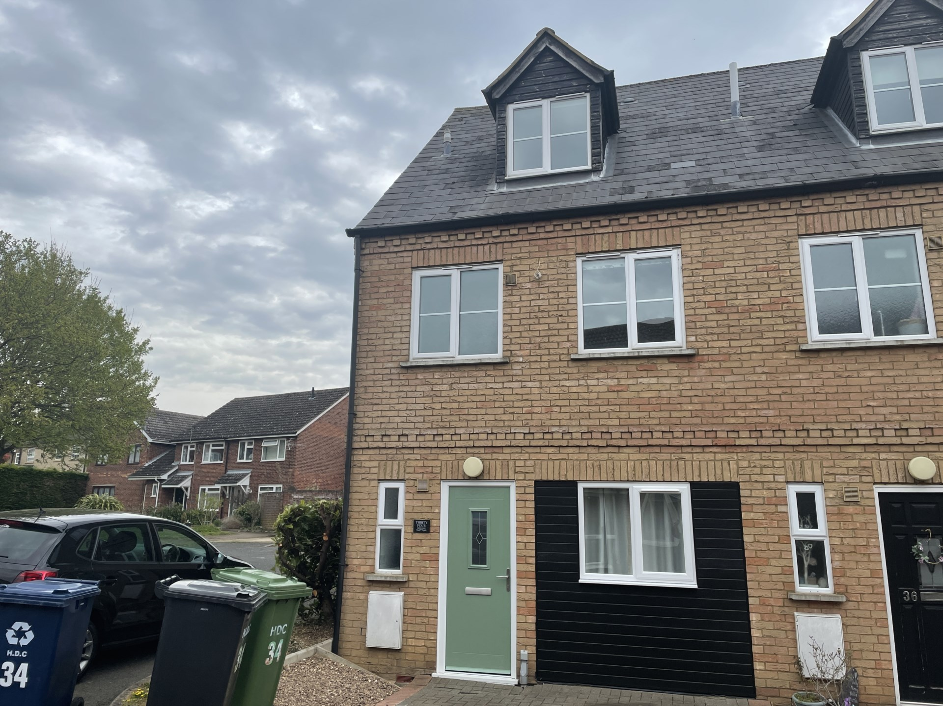



Room 1, 34 Squires Court, St Neots, PE19 8PB

Asking Price

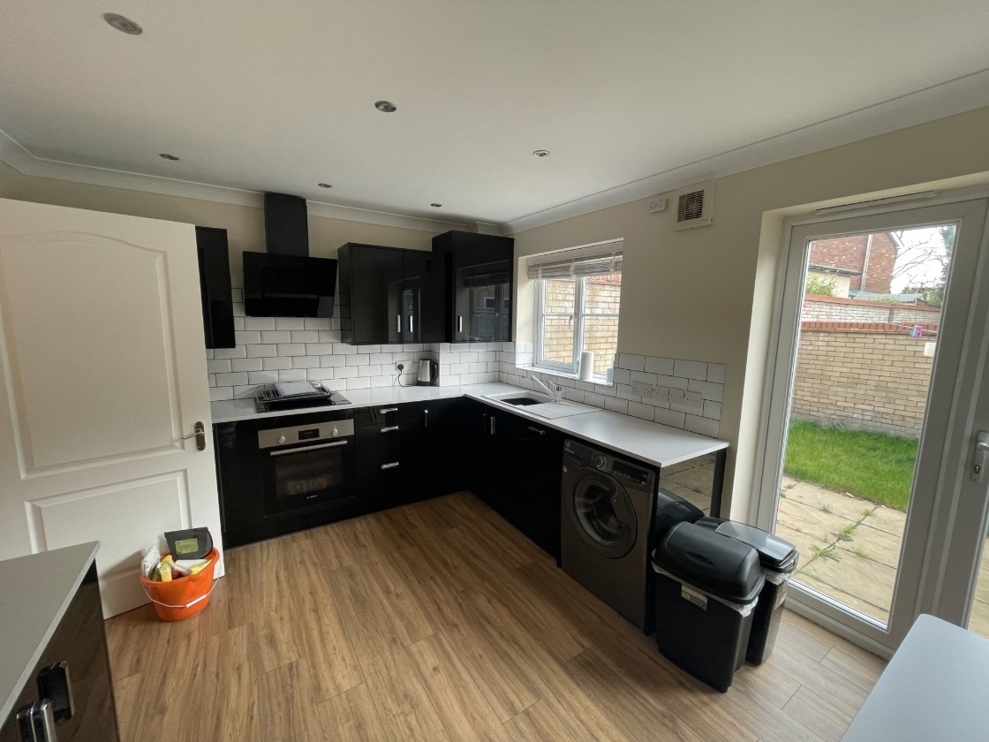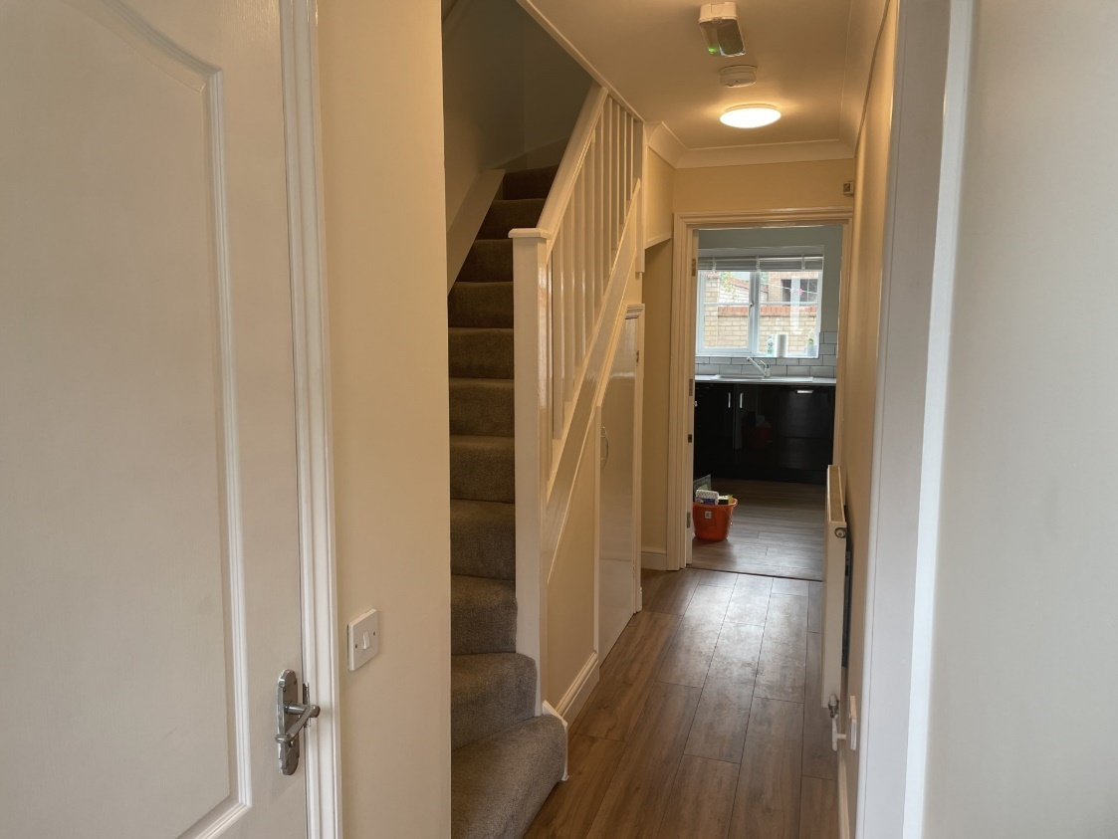

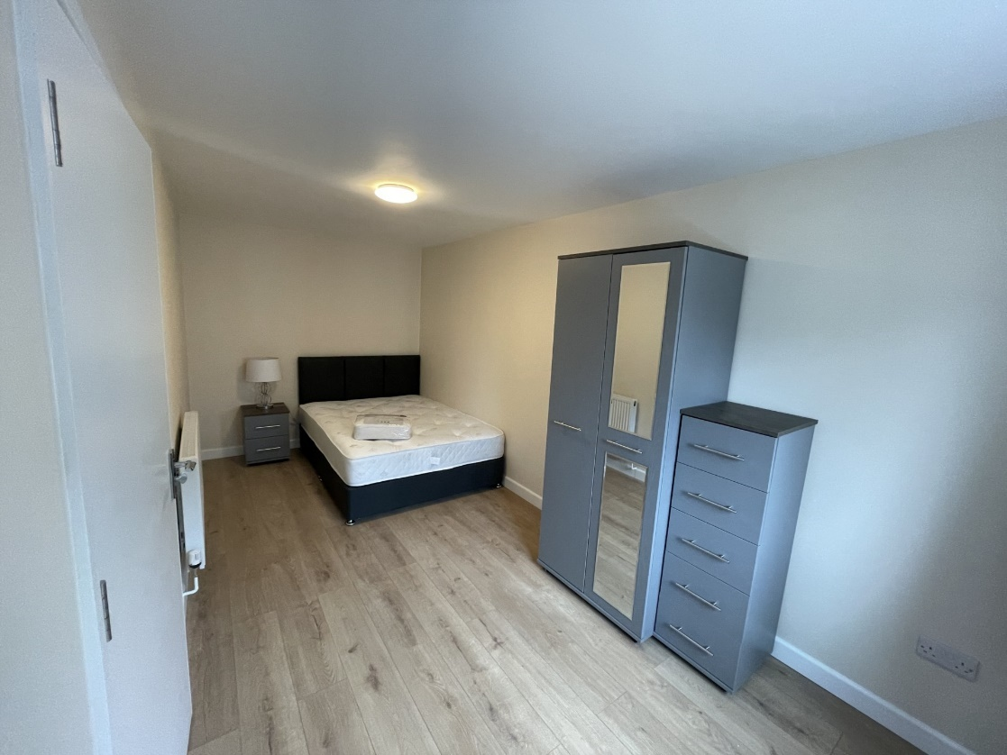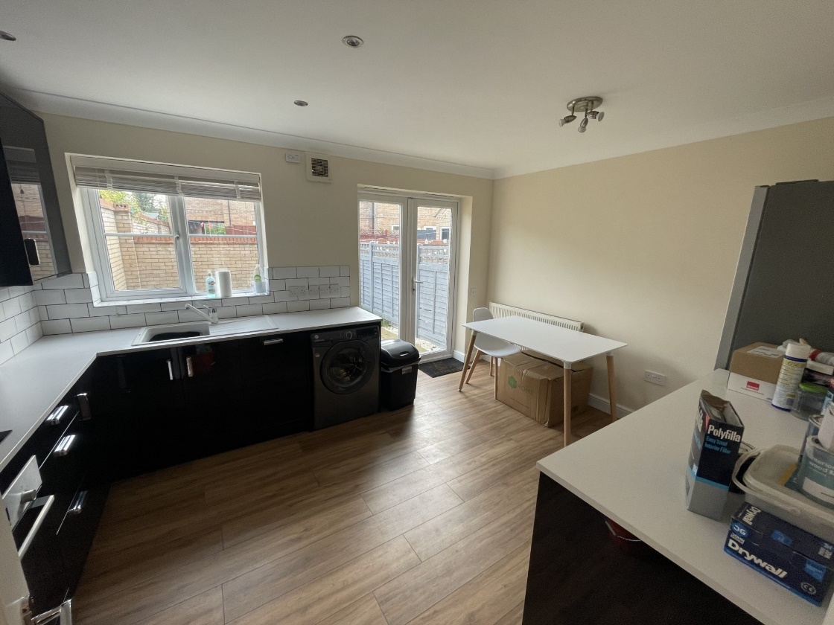

Total Deposit - £634.60

Rent - £550pcm

Annafield Estates are proud to offer for rent for the first time this one bedroom within an HMO. Located central to local amenities and close to St Neots Town Centre. The property benefits from having been recently redecorated with a new double bed and assorted furniture. The tenant will have full use of a modern fully equipped kitchen, modern three piece suite with shower over the bath, WC cloakroom and enclosed rear garden.

All bills: gas, electric, water, council tax and broadband included in the rent.

Available immediately.

Viewing highly recommended

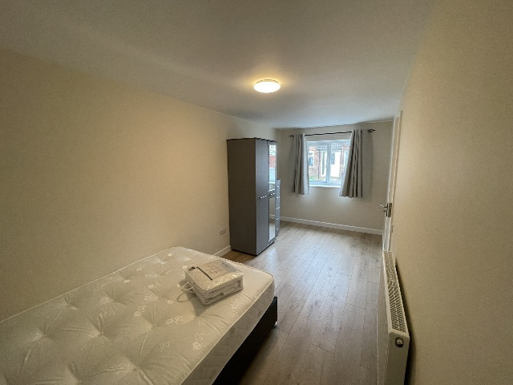



**Viewing by appointment only 01480 587678**

[enquiries@annafieldestates.co.uk](mailto:enquiries@annafieldestates.co.uk)

32 High Street, Buckden, St.Neots, PE19 5XA

**www.annafieldestates.co.uk**